**Expt No.: 3 Name: Swaranjana Nayak**

**Date: 17/10/2020 Reg. No.: 19BCE0977**

**CYCLE SHEET 3**

**Aim:**

To solve the given problems by implementing in SQL.

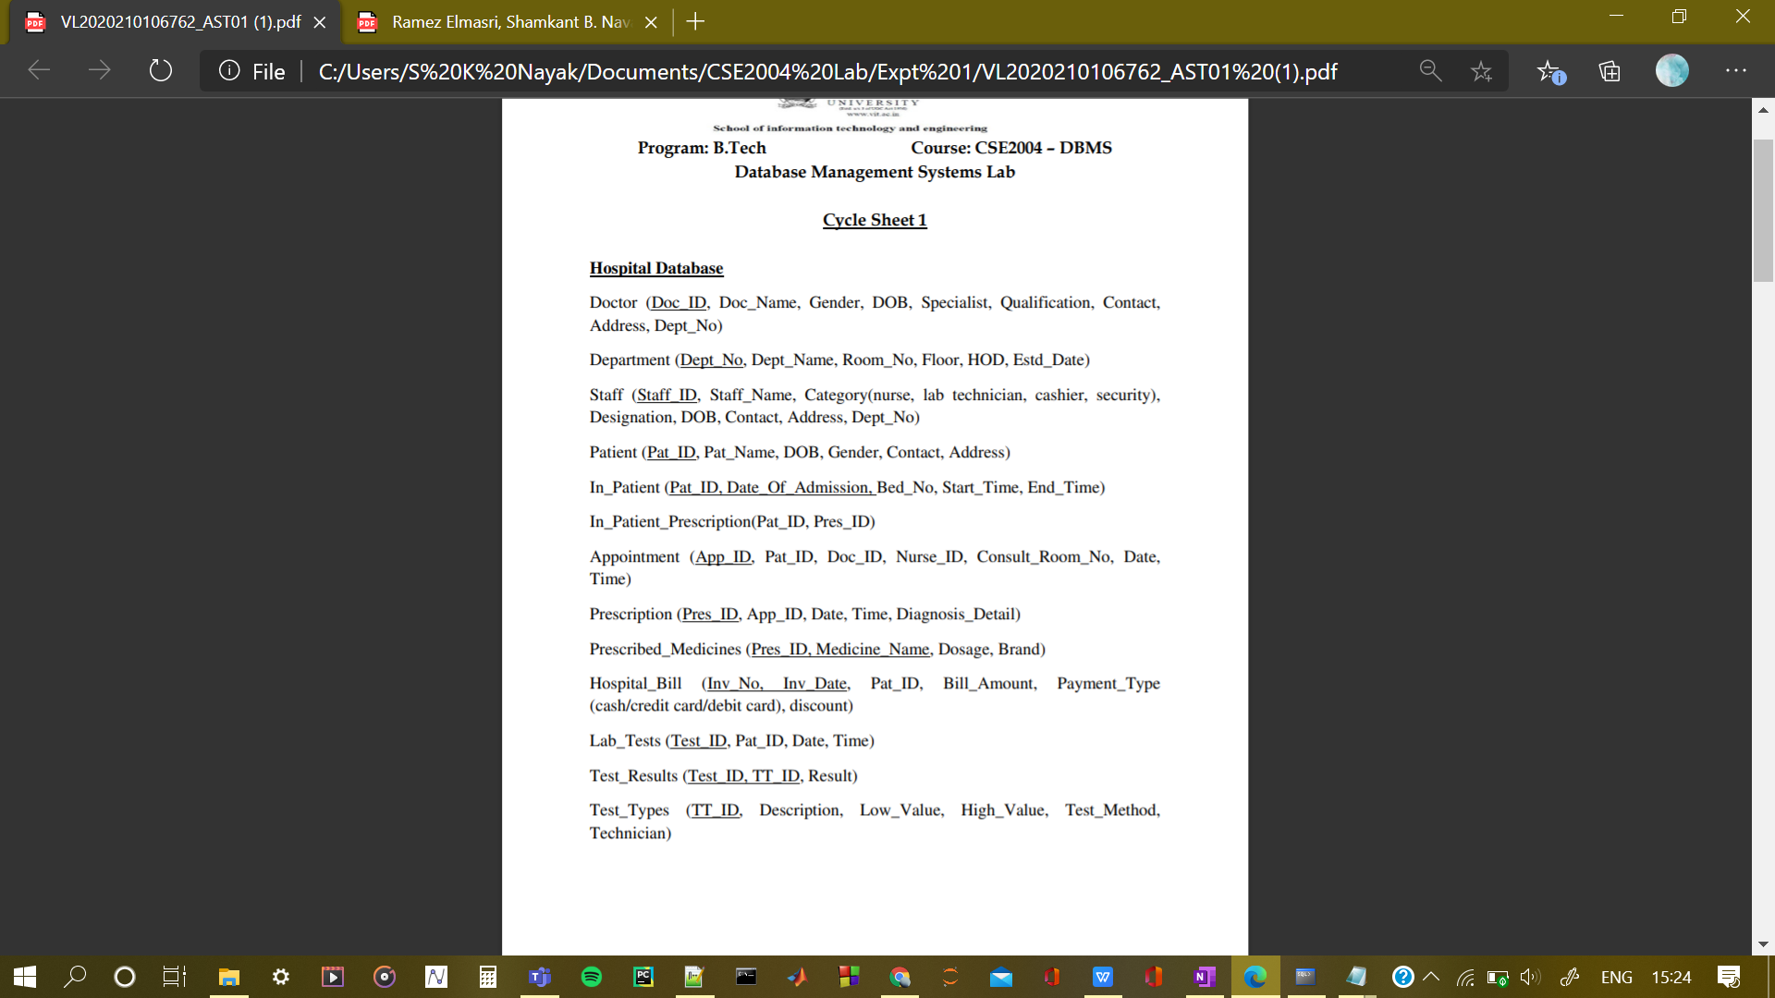

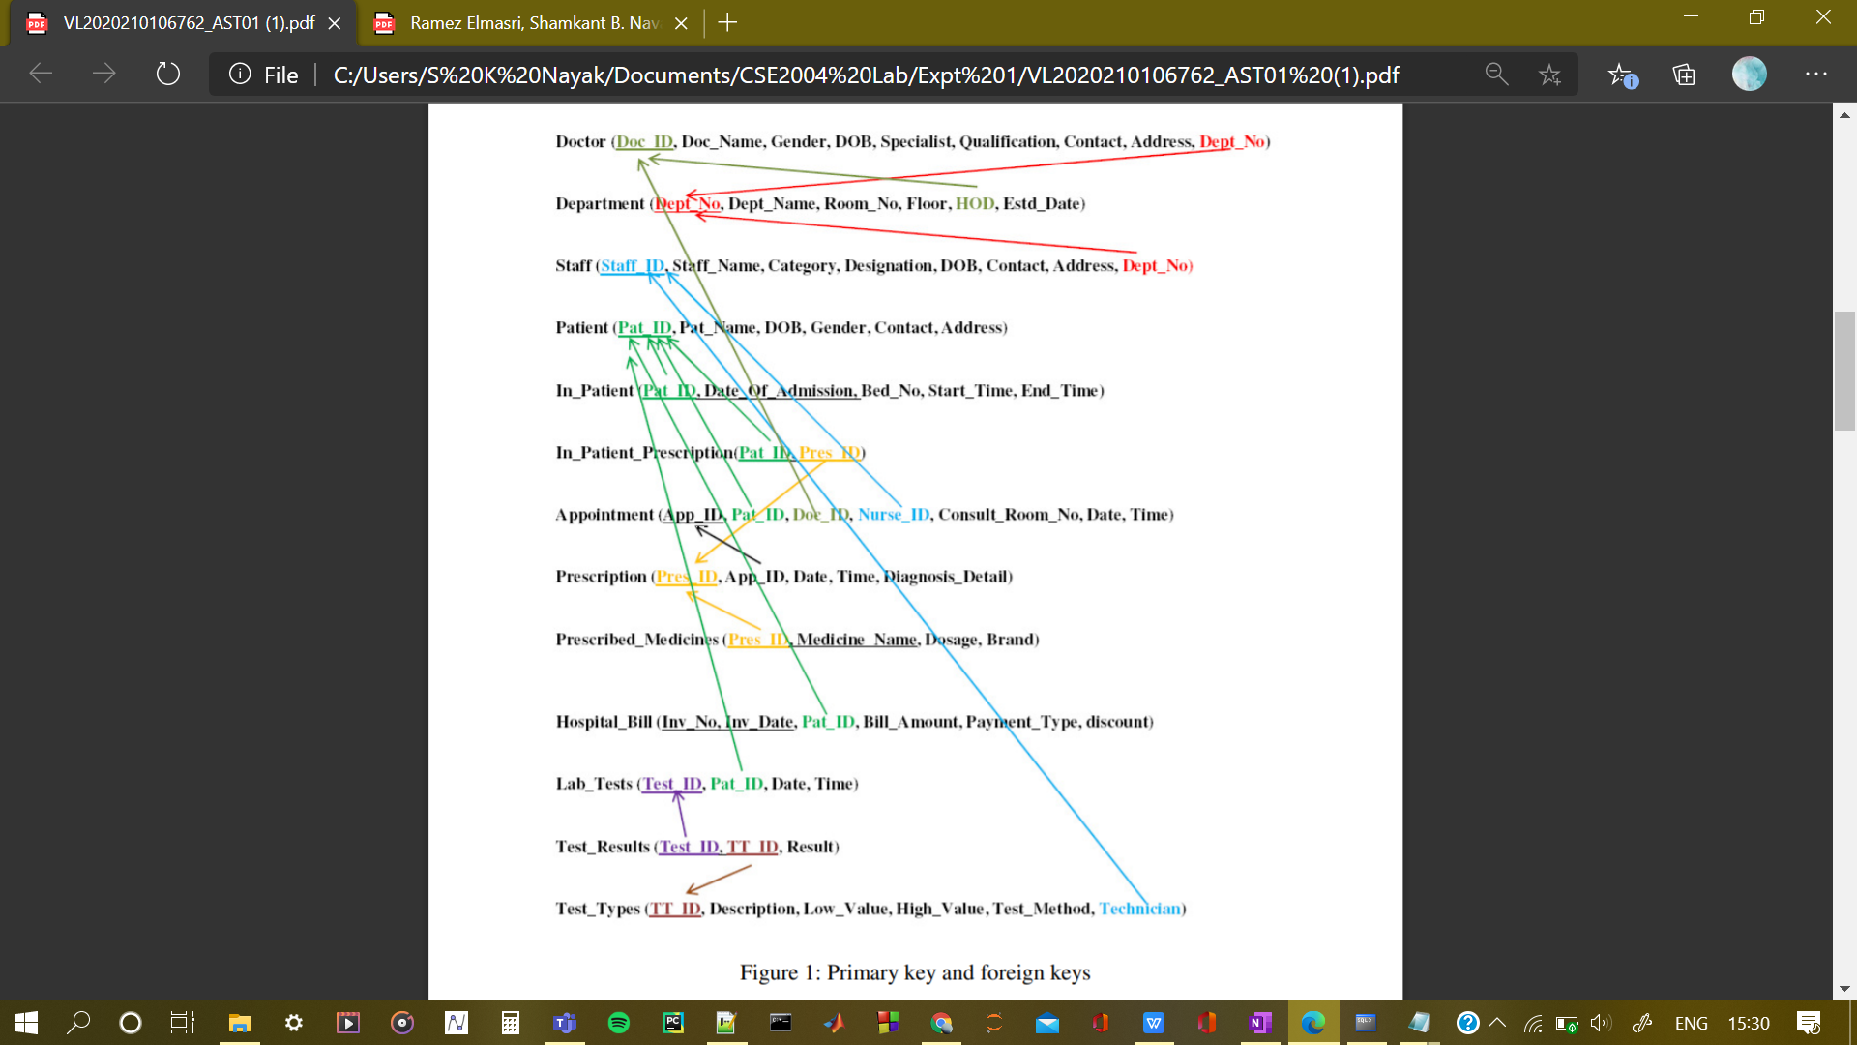

1. **Write a PL/SQL program to implement a simple calculator**

**Code:**

declare

num1 integer;

num2 integer;

resu integer;

op varchar2(5);

begin

num1 := &num1;

num2 := &num2;

op := '&op';

if op = '+' then

resu := num1 + num2;

else if op = '-' then

resu := num1 - num2;

else if op = '*' then

resu := num1 * num2;

else if op = '/' then

resu := num1 / num2;

end if;

end if;

end if;

end if;

dbms_output.put_line(resu);

end;

**Output:**

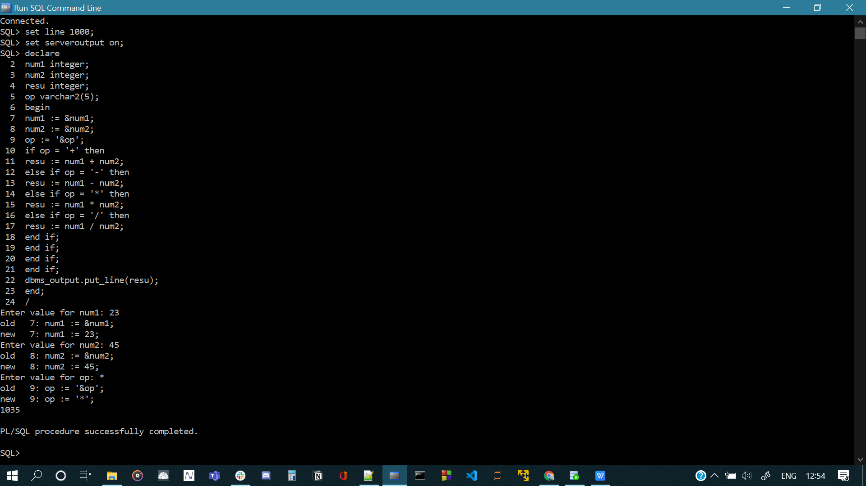

1. **Write a PL/SQL program to practice reading the record from a table into local variables using different data types and %TYPE and display the same using locally declared variables.**

**Code:**

declare

did doctor.doc_id%type;

dna doctor.doc_name%type;

gen doctor.gender%type;

dob doctor.dob%type;

spe doctor.specialist%type;

con doctor.contact%type;

dep doctor.dept_no%type;

begin

did := '&did';

select doc_name into dna from doctor where doc_id = did;

select gender into gen from doctor where doc_id = did;

select dob into dob from doctor where doc_id = did;

select specialist into spe from doctor where doc_id = did;

select contact into con from doctor where doc_id = did;

select dept_no into dep from doctor where doc_id = did;

dbms_output.put_line('Doctor ID:');

dbms_output.put_line(did);

dbms_output.put_line('Doctor Name: ');

dbms_output.put_line(dna);

dbms_output.put_line('Doctor Gender: ');

dbms_output.put_line(gen);

dbms_output.put_line('Specialization: ');

dbms_output.put_line(spe);

dbms_output.put_line('Contact: ');

dbms_output.put_line(con);

dbms_output.put_line('Department Number: ');

dbms_output.put_line(dep);

end;

**Output:**

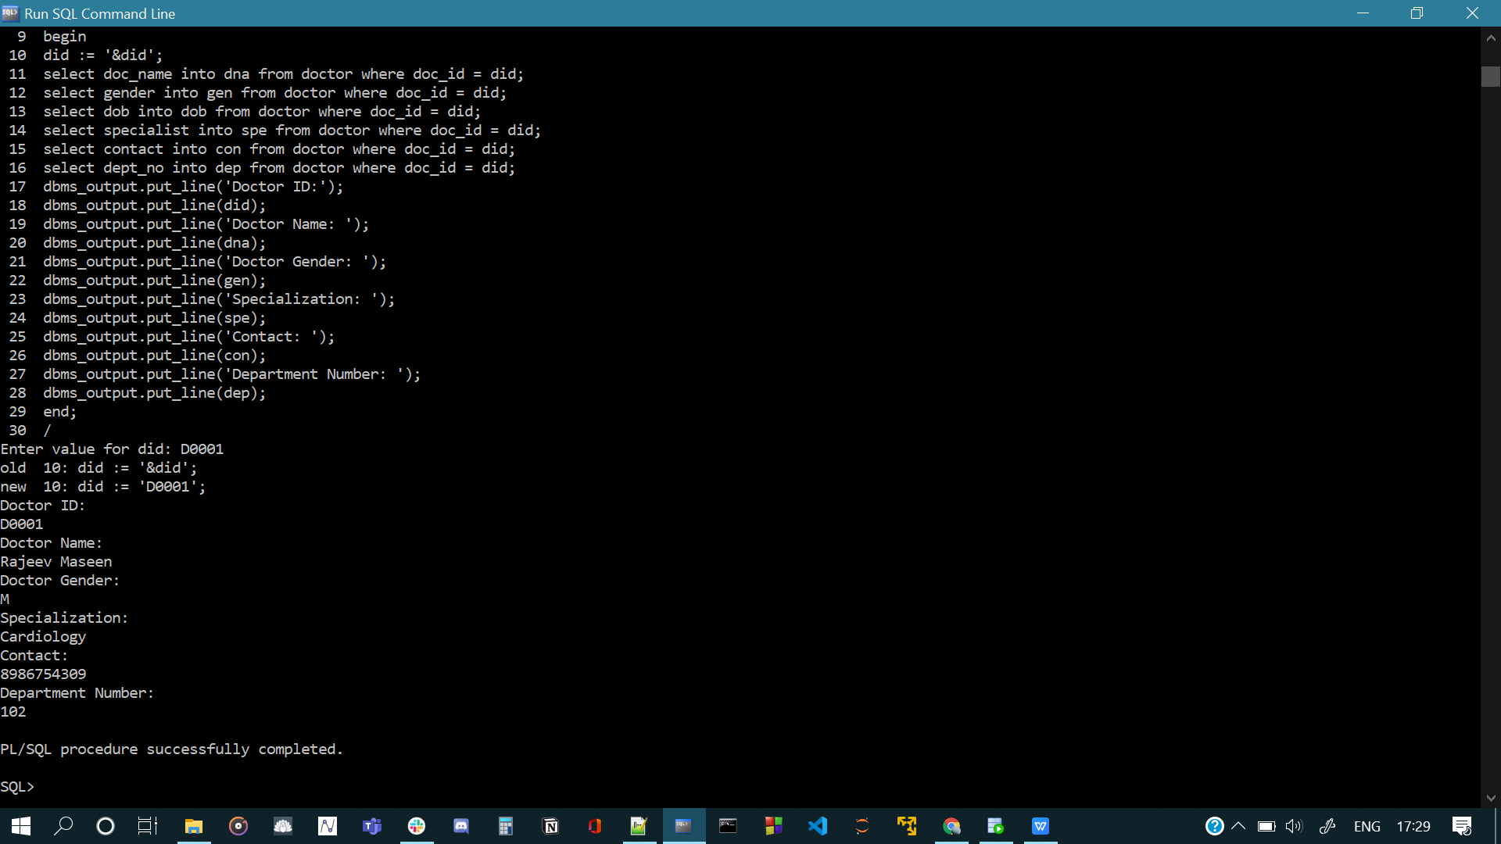

1. **Write a PL/SQL program to find the number of doctors in a given department with a given qualification (read values for department and qualification from user during runtime). If number is more than the number of doctors in that department with other qualifications then display ‘Well qualified’ else ‘Qualified’.**

**Code:**

declare

dep doctor.dept_no%type;

qua doctor.qualification%TYPE;

dc number(3) := 0;

qc number(3) := 0;

begin

dep := &dep;

qua := '&qua';

select count(*) into dc from doctor where dept_no = dep;

select count(*) into qc from doctor where dept_no = dep and qualification = qua;

if qc > (dc - qc) then

dbms_output.put_line('Well Qualified');

else

dbms_output.put_line('Qualified');

end if;

end;

**Output:**

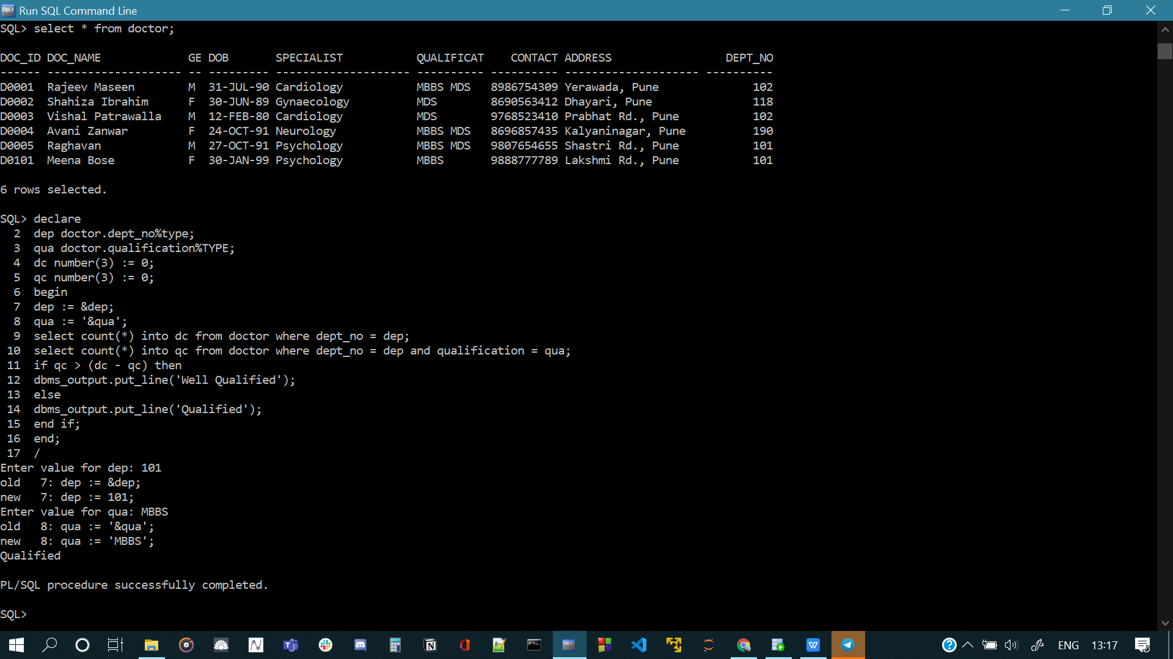

1. **Write a PL/SQL program to insert records into any of the tables in your database.**

**Code:**

SQL> declare

2 mn medicines.med_name%type;

3 br medicines.brand%type;

4 md medicines.manu_date%type;

5 ed medicines.exp_date%type;

6 begin

7 mn := '&mn';

8 br := '&br';

9 md := '&md';

10 ed := '&ed';

11 insert into medicines values(mn, br, md, ed);

12 commit;

13 dbms_output.put_line('Values inserted');

14 end;

15 /

**Output:**

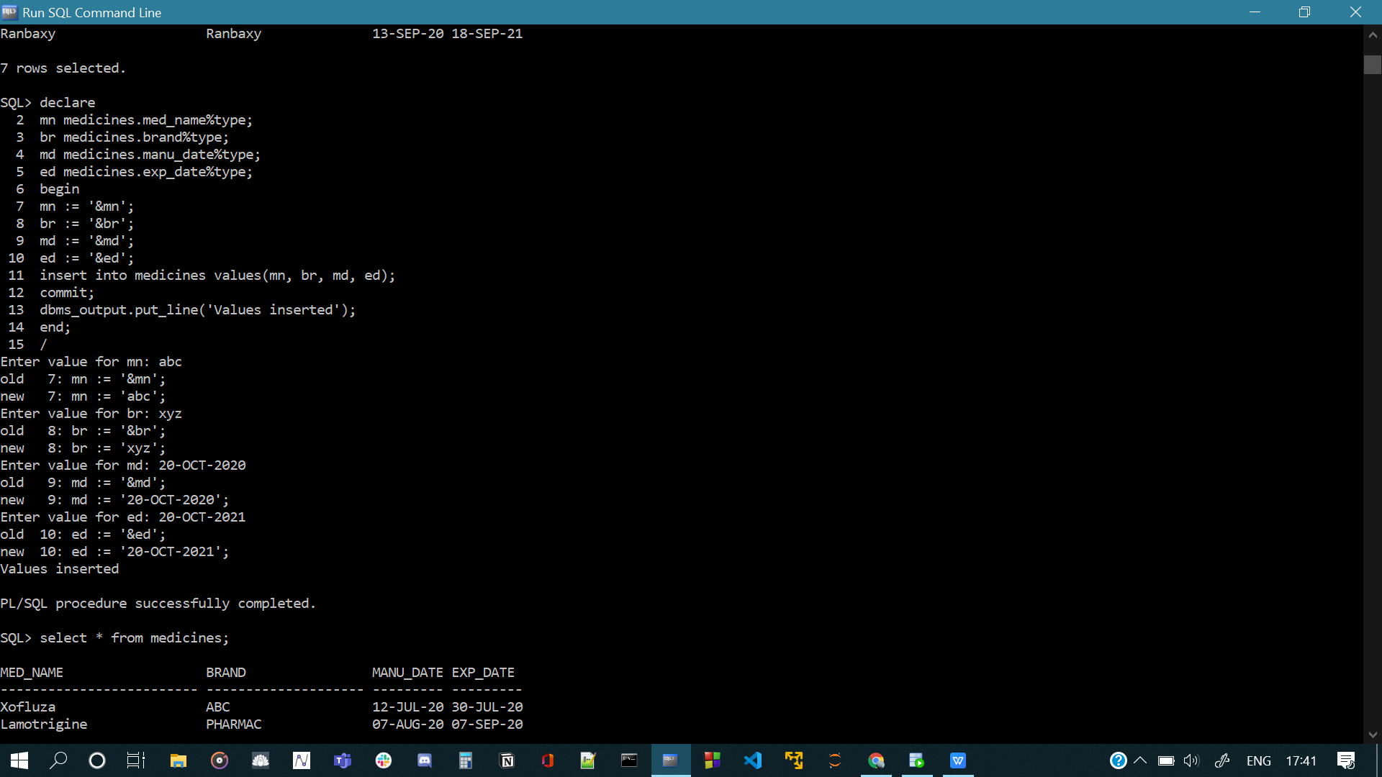

1. **Create a function to find the factorial of a given number.**

**Code:**

SQL> create or replace function factorial_mine(num number)

2 return number is

3 i number;

4 f number;

5 begin

6 if (num = 0 or num = 1) then

7 return(1);

8 else

9 f := 1;

10 for i in 1..num

11 loop

12 f := f*i;

13 end loop;

14 return f;

15 end if;

16 end;

17 /

SQL> declare

2 num number;

3 begin

4 num := &num;

5 dbms_output.put_line(factorial_mine(num));

6 end;

7 /

**Output:**

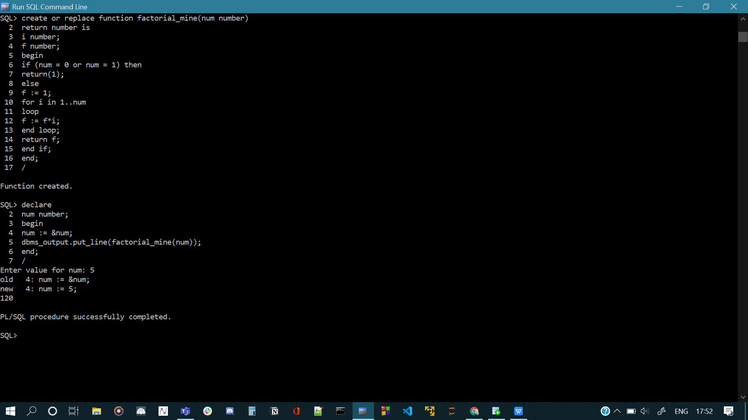

1. **Create a function DOC_COUNT to find the number of doctors in the given department. Use the department name as the input parameter for the function.**

**Code:**

create or replace function doc_count(dep doctor.dept_no%type)

return number is

cou number;

begin

select count(*) into cou from doctor where dept_no = dep;

return cou;

end;

declare

dep doctor.dept_no%type;

dc number(3) := 0;

begin

dep := &dep;

dc := doc_count(dep);

dbms_output.put_line(dc);

end;

**Output:**

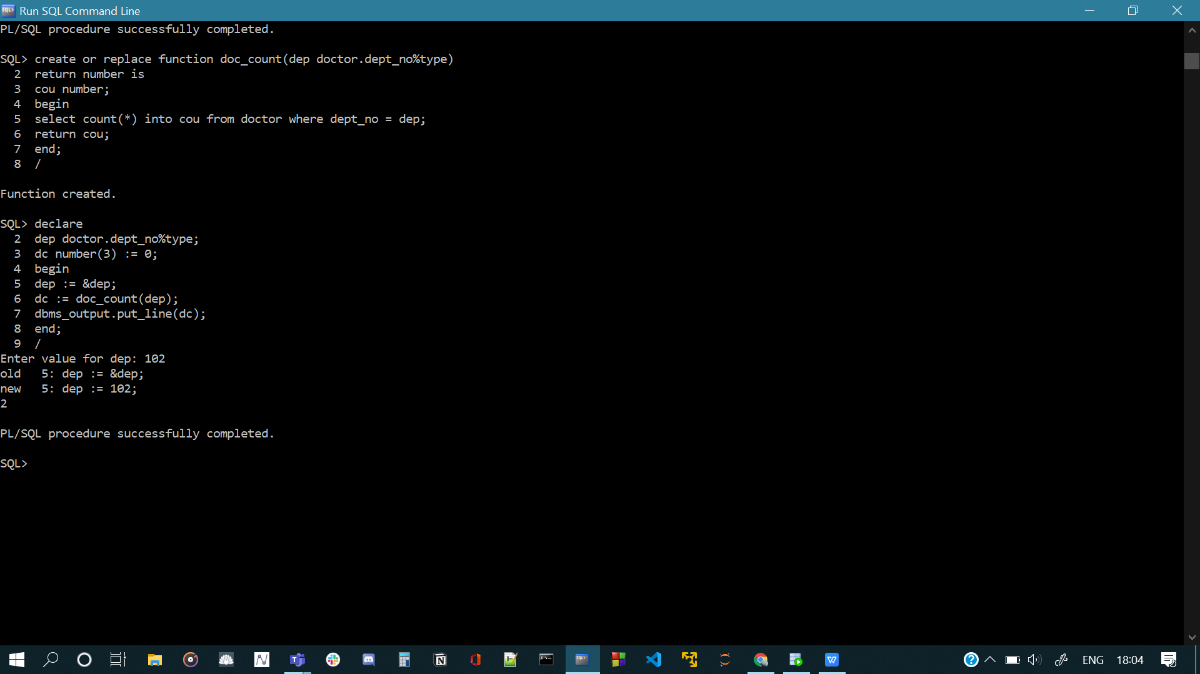

**Cursors:**

1. **Write a CURSOR to give 5% additional discount to all senior citizen patients.**

**Code:**

SQL> declare

2 cursor c is select pat_id, age, discount from patient natural join hospital_bill;

3 pid patient.pat_id%type;

4 age patient.age%type;

5 dis hospital_bill.discount%type;

6 begin

7 open c;

8 loop

9 fetch c into pid, age, dis;

10 exit when c%notfound;

11 if age > 45 then

12 dis := dis + 5;

13 dbms_output.put_line(dis);

14 end if;

15 end loop;

16 close c;

17 end;

18 /

**Output:**

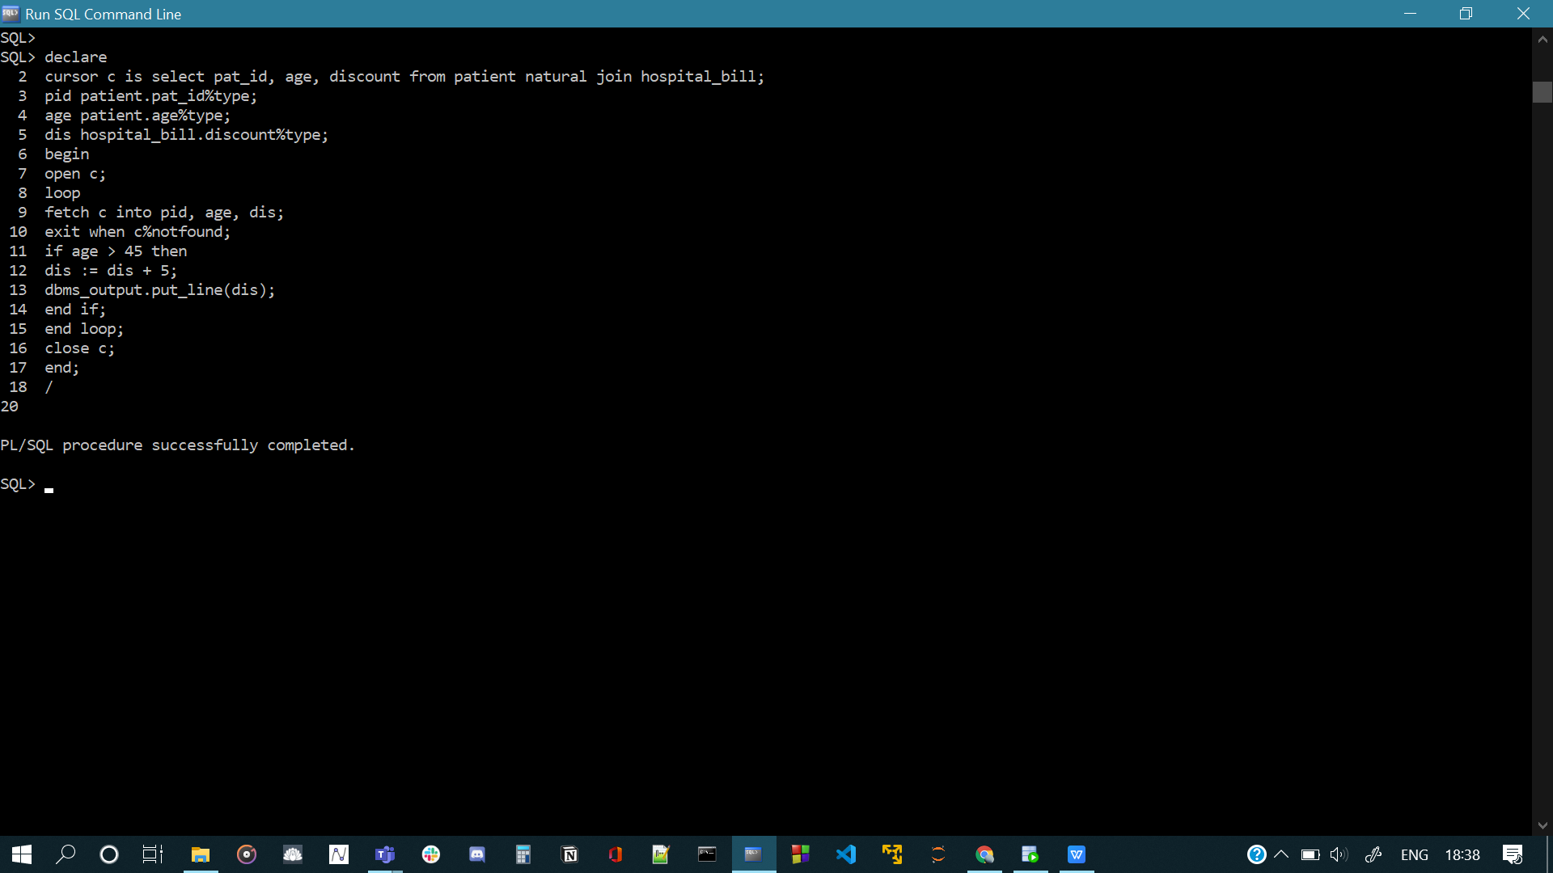

1. **Write a CURSOR to change the department number from 1 as 5 for all doctors with a qualification ‘MD’.**

**Code:**

declare

cursor c1 is select doc_id, qualification, dept_no from doctor;

did doctor.doc_id%type;

qua doctor.qualification%type;

dep doctor.dept_no%type;

begin

open c1;

loop

fetch c1 into did, qua, dep;

exit when c1%notfound;

if (qua = 'MD' and dep = 1) then

update doctor set dept_no = 5 where doc_id = did;

dbms_output.put_line('Updated');

end if;

end loop;

close c1;

end;

**Output:**

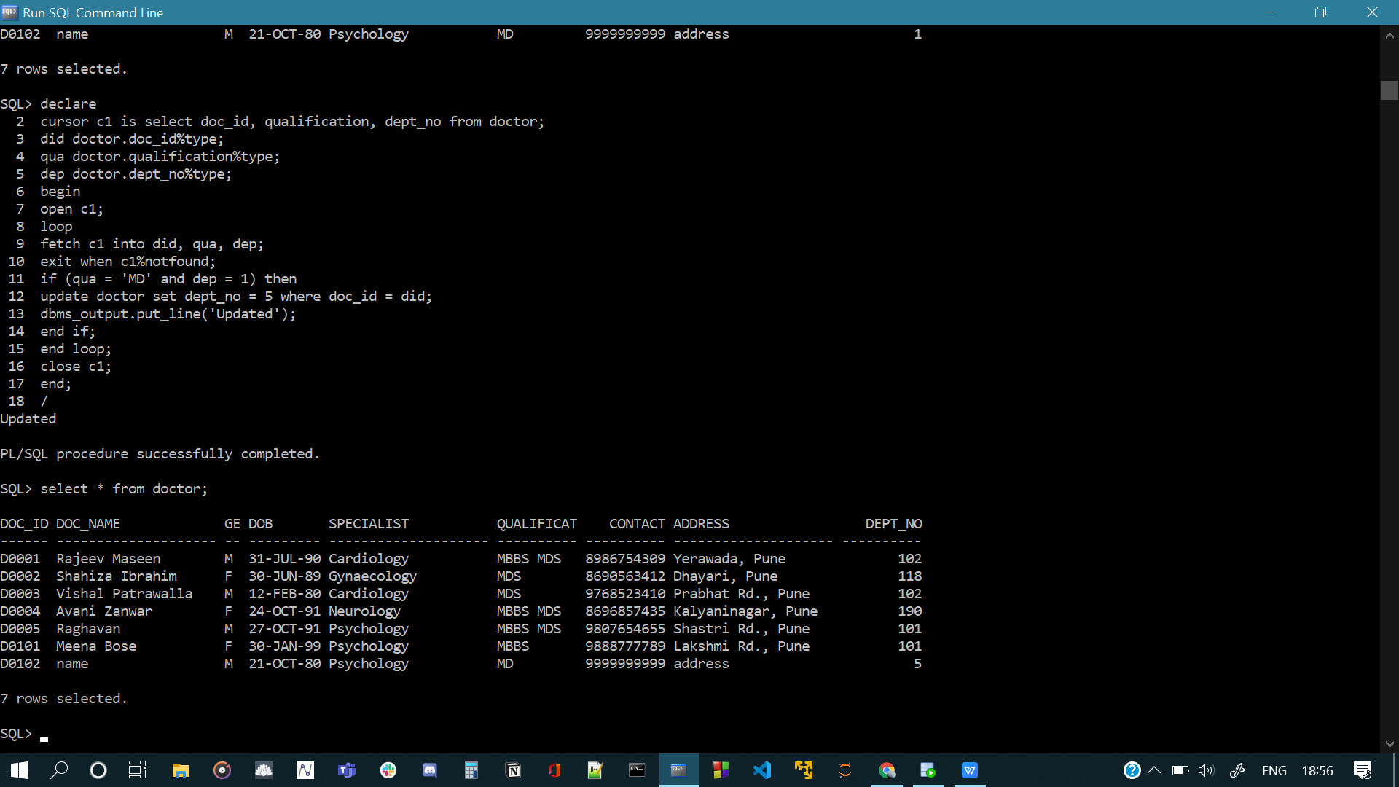

**Functions and Procedures:**

1. **Write a PL/SQL stored function COUNT_DOC to count the number of doctors who have treated at least 100 patients if given a doctor id as input parameter.**

**Code:**

create or replace function count_doc(n number)

return number is

cursor c2 is select doc_id, count(doc_id) from appointment group by doc_id;

cou number := 0;

did doctor.doc_id%type;

dco number;

begin

open c2;

loop

fetch c2 into did, dco;

exit when c2%notfound;

if dco >= n then

cou := cou + 1;

end if;

end loop;

close c2;

return cou;

end;

**Output:**

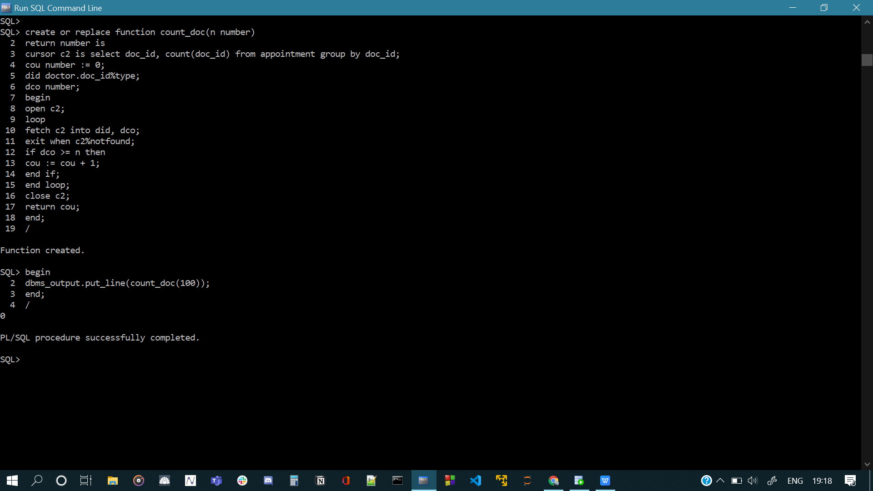

1. **Write a PL/SQL stored procedure to adjust the payment type of hospital bills to CASH if the patient id and amount details given as input.**

**Code:**

create or replace procedure cash(pid patient.pat_id%type, amt hospital_bill.bill_amount%type)

is

begin

update hospital_bill set payment_type = 'CASH' where pat_id = pid and bill_amount = amt;

end;

declare

pid patient.pat_id%type;

amt hospital_bill.bill_amount%type;

begin

pid := '&pid';

amt := &amt;

cash(pid, amt);

dbms_output.put_line('Updated');

end;

**Output:**

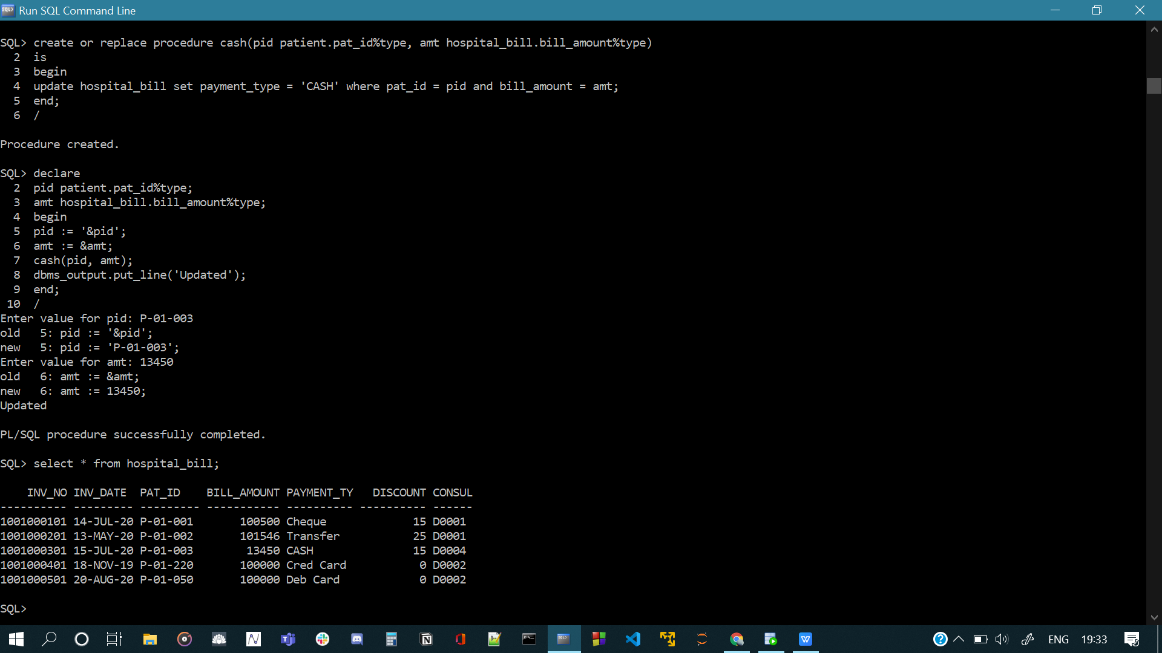

**Triggers:**

**Add an attribute with patients table to store the age of the patients. Then answer the following question;**

1. **Write a Trigger to find and fill the age of a patient whenever a patient record is inserted into patients table.**

**Code:**

create or replace trigger age_patient

before insert on patient

for each row

declare

a patient.age%type;

pid patient.pat_id%type;

begin

pid := :old.pat_id;

a := 2020 - extract(year from :old.dob);

update patient set age = a where pat_id = pid;

end;

**Output:**

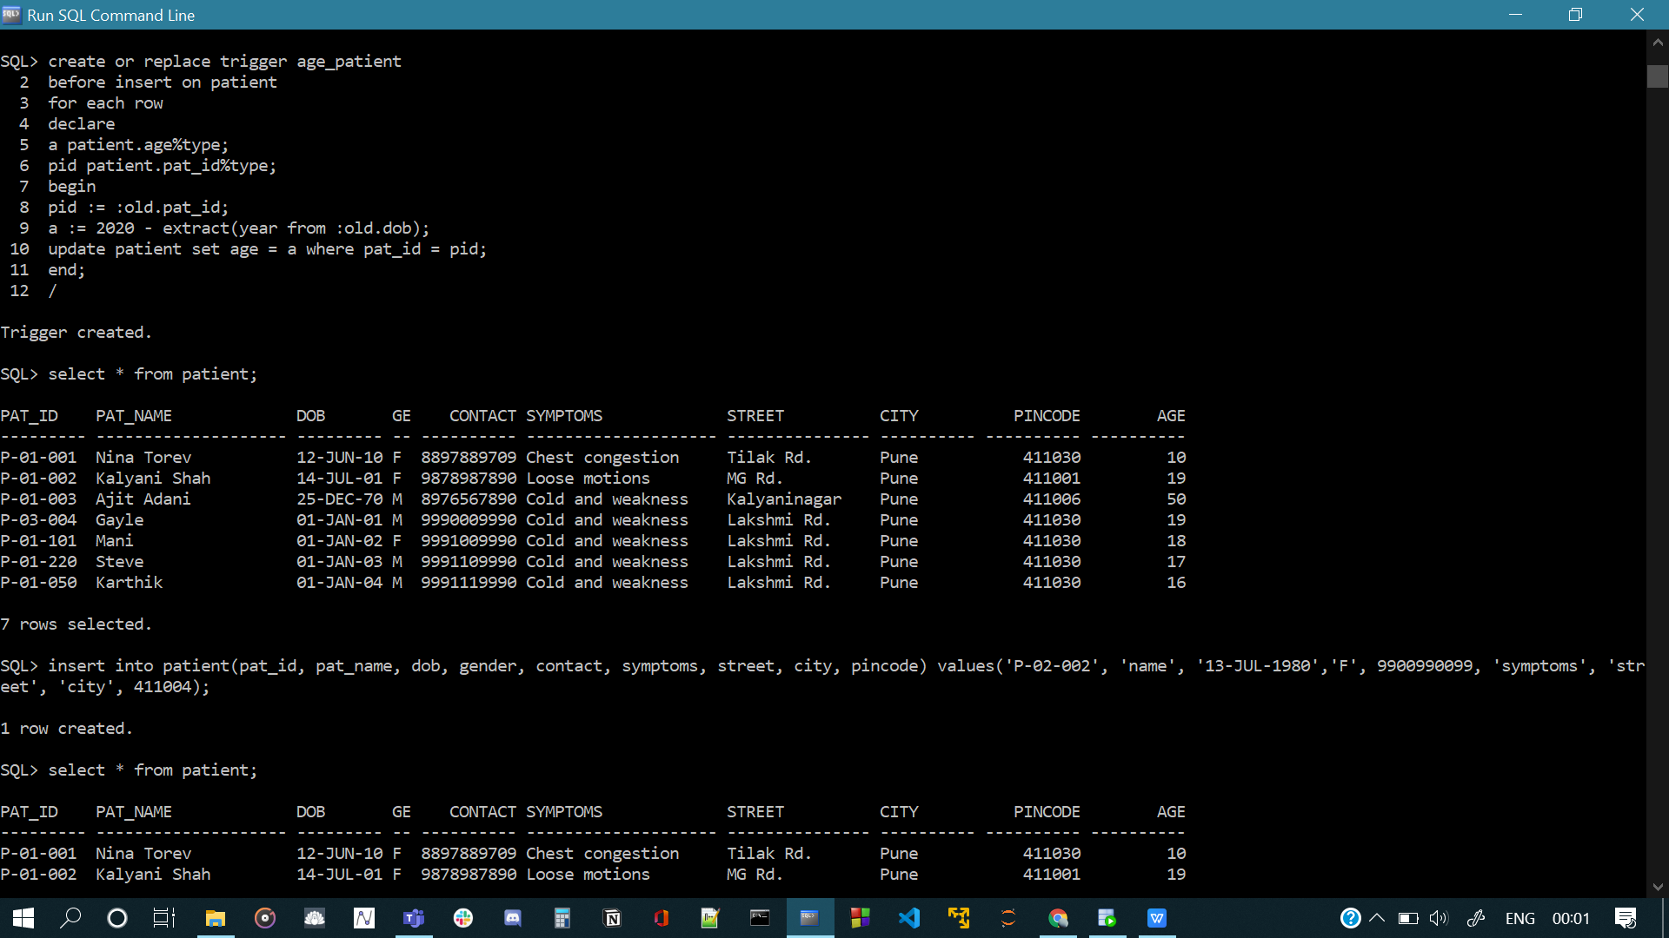

**Create a table EMP_SALARY with attributes ID, Basic, DA, HRA, Deduction, Net_Salary. Here, ID refers the Staff_ID of staff table. Treat ‘Net_Salary’ as a derived attribute and don’t insert a value through insert operation. The value for Net Salary can be calculated as follows; Net_Salary = Basic + DA + HRA – Deduction**

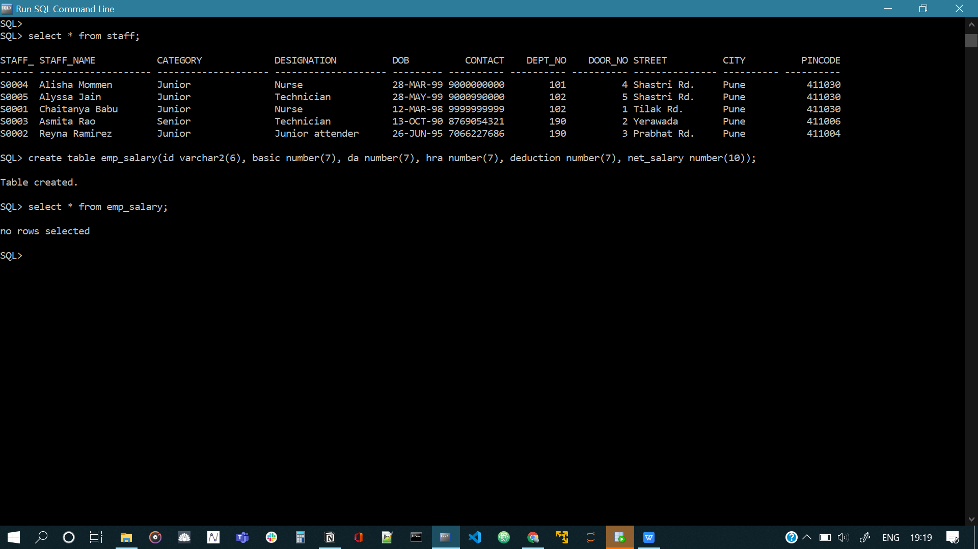

1. **Write a Trigger to perform the following; whenever new staff is recruited and a designation is assigned, insert an appropriate record into EMP_SALARY table. Refer the following table for salary details.**

**Code:**

create or replace trigger insert_emp_salary

after insert on staff

for each row

enable

begin

if :new.Designation = 'Staff nurse' then

insert into emp_salary values (:new.Staff_Id, 6000, 6000, 2000, 2, (6000 + 6000 + 2000 - (0.02*6000)));

ELSIF :new.Designation = 'Head nurse' then

insert into emp_salary values (:new.Staff_Id, 8000, 2500, 3000, 2, (8000 + 2500 + 3000 - (0.2*8000)));

ELSIF :new.Designation = 'Technician' THEN

INSERT INTO emp_salary VALUES (:new.Staff_Id, 6000, 2000, 2000, 2, (6000 + 2000 + 2000 - (0.2*6000)));

ELSIF :new.Designation = 'Senior technician' THEN

INSERT INTO emp_salary VALUES (:new.Staff_Id, 9000, 2500, 3500, 2, (9000 + 2500 + 3500 - (0.2*9000)));

ELSIF :new.Designation = 'Junior attender' THEN

INSERT INTO emp_salary VALUES (:new.Staff_Id, 5000, 1500, 2000, 2, (5000 + 1500 + 2000 - (0.2*5000)));

ELSIF :new.Designation = 'Senior attender' THEN

INSERT INTO emp_salary VALUES (:new.Staff_Id, 6500, 2000, 2000, 2, (6500 + 2000 + 2000 - (0.2*6500)));

END IF;

END;

**Output:**

